**Outcome Variable EDA**

1. Standardize and Adjust all the data
2. Merge
3. Summary stats
4. Changes over time: abortion_rate, birth_rate, pregnancy_rate all decrease; hiv rate doesn’t change too much; std rate varies, almost all states just begin to decrease these years, but in some states still increase

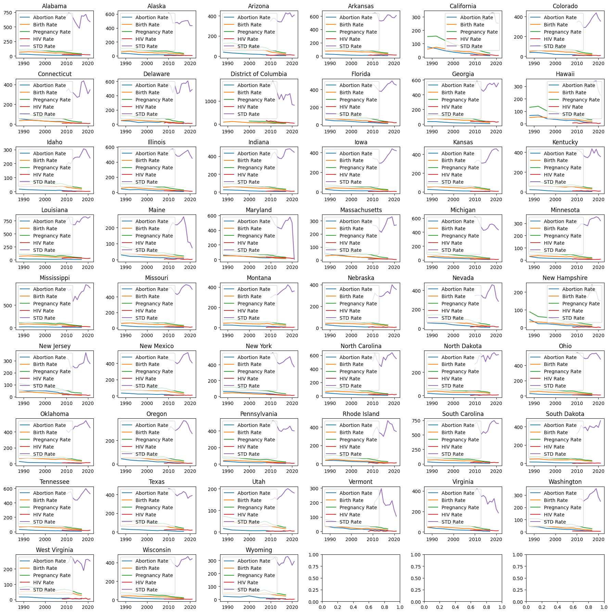

1. Correlation: these outcome variables are all positive correlated.

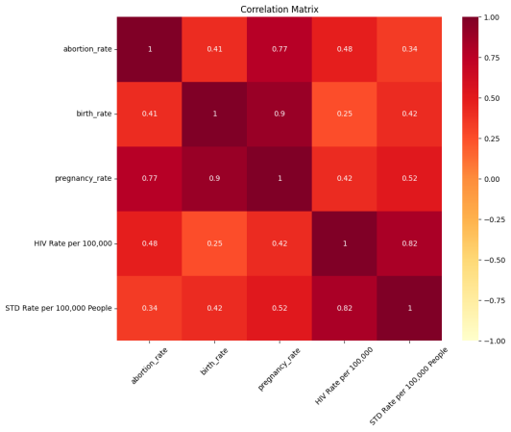

1. Clustering: based on time-series change types (STL Decomposition) between 2010 to 2017 to cluster 5 groups